**12 Sept 2014** **The Weekly Bulletin of Rotary Club of Kathmandu Mid-Town** **bc-11/9.014**

|  |
| --- |
|  |

District: 3292 Web:www.rotarymidtown.org.np Club Id: 26776

**SEPTEMBER IS NEW GENERATIONS MONTH**

**Celebrating**

**25 Years in Rotary**





Friday, 5 September : Extracts of the Minutes # 1245

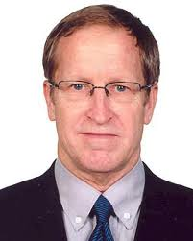

“Acting President Peter also highlighted about the importance of UNHCR. He said that it is such

an organization that never fails.

“Rtn KNS introduced the Guest Speaker Craig Sanders, UNHCR Rep.

“Mr. Sanders at the beginning of his presentation pointed out that Ms. Yukiko had received

Rotary Scholarship.

“Mr. Sanders during his presentation said that there are around 51 million people displaced

globally of which around 30 million is displaced from the Syria crisis alone. "The Business

that we all do is becoming more dangerous". He said that the people and the government of

Nepal are very hospitable in the case of refugees. With regards to Tibetan refugees in Nepal, the main issue is that of documentation. Seventy five percent do not have any valid documents which is a serious issue. Around 92,000 Bhutanese refugees have been resettled in eight different countries of which 77,000 alone have been settled in US alone. Mr. Sanders also talked about Urban Refugees. There are around 500 refugees and asylum seekers from Africa, Pakistan & Afganisthan. Mr. Sanders also stressed the importance of citizenship and the case of Nepal where both father and mother must be Nepali for one to obtain Nepalese Citizenship.

“Rtn Asko, Rtn Buddha & PP Saroj took part in the discussion. To Asko's query, Sanders said that UNHCR do not follow up with what is happening with the life of resettled refugees and to Buddha's query, Sander said that TB patients are accepted in the US. Acting President Peter said that 2-3 million people in Nepal could not vote in the last general election because of lack of citizenship certificate.

“Rtn Asko gave vote of thanks to Mr. Sanders.”

><><><><><><><>

Information Sharing:

- “Rtn Amar informed about the signing of MOU between the Autonomous Province of Bolzano/Bozen (Italy) and the

Kathmandu Metropolitan City Office regarding upgrade of KMC fire brigade by donation of fire engines, fire fighter

equipment and firefighting clothes as well as training initiatives;

- “Treasurer Jo informed that the Bank problem was finally solved and the cheques could now be issued;

- “Rtn Rabi informed that Rotary, Rotaract & Interact Club of Kathmandu Mid Town have collectively collected Rs

155,000/- for flood/landslide victims;

- “Acting President Peter informed that US embassy here in Nepal has also started initiatives to support communities that

the people do not lose everything during such disasters.

- “Members present: 31”

# Weekly Meetings and Prorams :

|  |  |  |
| --- | --- | --- |
| Date | Program/Speaker | Program/Topics of Presentation |
| 12 September | Dr Bhekh Bd Thapa | Initiation in Gulf, foreign policy, land reform etc |
| 19 September | Pitamber Sharma |  |
| 26 September | CAS Gaurav Shamsher Rana |  |
|  |  |  |

Friday, 12 September

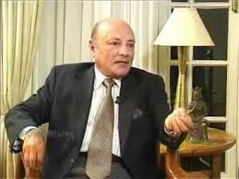

Dr Bhekh B Thapa is our guest speaker. He will be talking on his initiations in Gulf,

some Issues of our foreign policy and land reform. He is currently the Chairperson

of the Board of Directors of Nick Simons Institute (NSI), a philanthropic organization,

established with the mission to train and support rural healthcare workers.

He was appointed as Minister of Foreign Affairs in March 2004 in the cabinet of

PM Surya Bahadur Thapa. Before that he served as Nepal's Ambassador-at-large with

cabinet rank and participated as de-facto Foreign Minister in such fora as the SAARC

Summit and the BIMSTEC conference. He also took an active role in negotiating with

the Bhutanese government on the Bhutanese refugee issue, as well.

Dr Thapa was previously the Ambassador to India, considered Nepal's most important diplomatic posting, from 1997 to 2003. He served twice as Nepal's Ambassador to the United States, arguably the second most important diplomatic post, first from 1980-1985 and in 1996. He also served as the United Nations Resident Coordinator in Sri Lanka from 1986 to 1990, and then was appointed for a two-year term as Senior Advisor for Administration at the UN Development Program in Geneva.

Dr. Thapa served as the Minister of State for Finance in 1975, was promoted to Minister of Finance in 1976, and remained in the post until 1978. Previously he held the senior civil service position in the Ministry of Finance as Secretary from 1969 to 1971. Thapa also served as the Governor of Nepal Rastra Bank, in1967, and as the Member Secretary of the National Planning Commission from 1961 to 1967.

Born in a village of Tanahu district in 1937 he graduated from Calcutta University and earned a Ph.D. in Economics from Claremont University, California in 1965.

In 1994, Dr. Thapa ran for office in the mid-term polls as an independent candidate from Tanahu district.

*Source:* Internet News

**International Day of Charity: 5 September**



It's not how much we give but how much love we put into giving : *Mother Terasa*

"Let us recognize charity for what it is at heart: a noble enterprise aimed

at bettering the human condition," Ban said in a message for the second

observance of the International Day of Charity.

Charity may come in many forms, from the volunteering of time and

expertise to straightforward financial or in-kind donations by individuals,

corporations or philanthropic foundations. "At times of intense fiscal

and budgetary constraint, charity takes on greater importance in global

efforts to achieve the Millennium Development Goals and implement

what we hope will be an ambitious post-2015 agenda," Ban noted.

It is also important to remember that charity cannot be seen as a

replacement or alternative to public spending, though it plays an

invaluable complementary role, he said. "On this International Day,

I call on people everywhere to act on the charitable impulse that resides

in every human being - to start giving and to keep on giving," the UN chief said. The International Day of Charity was proclaimed last year by a UN General Assembly resolution essentially recognizing the role of charity in alleviating human suffering.

The Day is observed on Sept. 5 annually to commemorate the anniversary of the death of Mother Teresa, who received the Nobel Peace Prize in 1979 for her work with the poor, sick, orphaned and dying in Calcutta, India.

*Source: Internet News*

**International Literacy Day : 8 September**

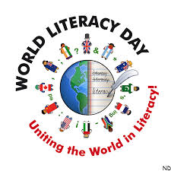

This year’s theme is “Literacy and Sustainable Development”.  Literacy is one of the key

elements needed to promote sustainable development, as it empowers people so that they

can make the right decisions in the areas of economic growth, social development and

environmental integration.  Literacy is a basis for lifelong learning and plays a crucial

foundational role in the creation of sustainable, prosperous and peaceful societies.

Literacy skills developed from a basic to advanced level throughout life are part of broader

competencies required for critical thinking, the sense of responsibility, participatory

governance, sustainable consumption and lifestyles, ecological behaviours, biodiversity

protection, poverty reduction, and disaster risk reduction.

This year’s International Literacy Day will be celebrated worldwide. A main global

celebration will take place in Dhaka, where the Government of Bangladesh in cooperation

with UNESCO will organize the International Conference on “Girls’ and women’s literacy

and education: Foundations for sustainable development and the awarding of UNESCO Literacy Prizes” in support for the UN Secretary General’s Global Education First Initiative (GEFI).

According to the [World Literacy Foundation](http://www.worldliteracyfoundation.org/The_Economic_&_Social_Cost_of_Illiteracy.pdf), an estimated 67 million children still do not have access to primary school education.

*Source: Internet News*

**Congratulations: Sharada Chitrakar**

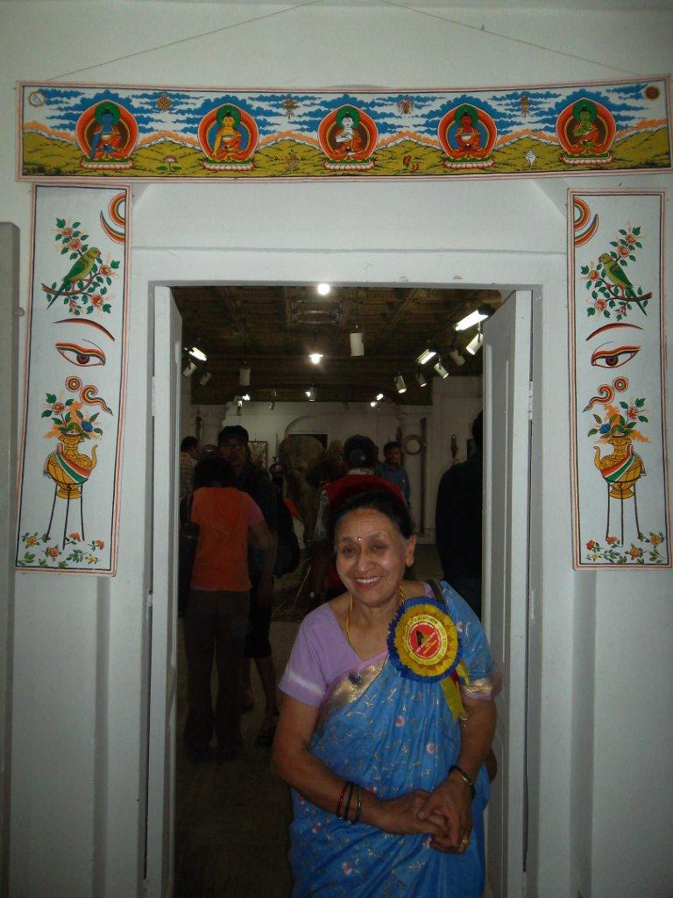

Ms Sharada Chitrakar has recently been nominated as

Vice-Chancellor of the Nepal Academy of Fine Arts (NAFA).

This is recognition of her untiring efforts and dedication during her

four year term as council member of the then newly formed

statutory body. She then led the Folk Arts Department and was

also shouldering the responsibility of promoting women artists.

She held a number of thematic art workshops and discussion

forums during the folk arts exhibitions.

She published four volumes of research works from the subject

experts on the diverse forms of folk arts - Newar, Maithili, Tharu,

Himali, and others. One of the publications was her own work for

which engaged herself in documentation of and research in the

ritual art of Newar community known as *punjya*

Born in the traditional painter family she had the privilege of being

taught in fine art and painting at a very young age by her late

father Tejbahadur Chitrakar, the pioneer contemporary artist/art

teacher of Nepal. She received prestigious award in the first

national paintings exhibition held way back in 1966.

She paints aquarelles and acrylics, as well as draws in pen and ink. She takes great interest in on-the-spot painting of nature, traditional architecture, and religious festivals. Her life time works were exposed first time in a grand solo exhibition held in 2002. Her second solo with her on- the- spot works was held in 2004. She finds herself relaxed and exhilarated in holding her brush or pen and ink. She seeks great pleasure in promoting children, youth, women, folk artists and others in the creative venture of art works.

Artist Sharada is the spouse of PP Komal Chitracar.

**Indrajatra:** 8 September

[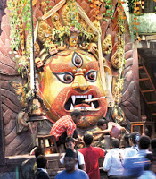](http://www.weallnepali.com/nepali-festivals)

[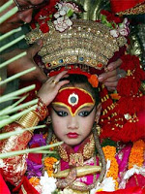](http://www.weallnepali.com/nepali-festivals)

Indra Jatra begins every year on Bhadra shukla dwadasi,12th day

of the bright fortnight,(6 Sept, this year) and lasts for eight days,

with the carnival-like erection of *Linga* (*Yasin*), a ceremonial pole,

accompanied by the rare display of the deity Akash Bhairab,

represented by a massive mask. The main venue of the festivities

is Kathmandu Durbar Square.

The celebrations consist of two events. Indra Jatra is marked by

masked dances of deities and demons, displays of sacred images

and tableaus in honor of the deity Indra, the king of heaven.

The other event is Kumari Jatra, the chariot procession of the living

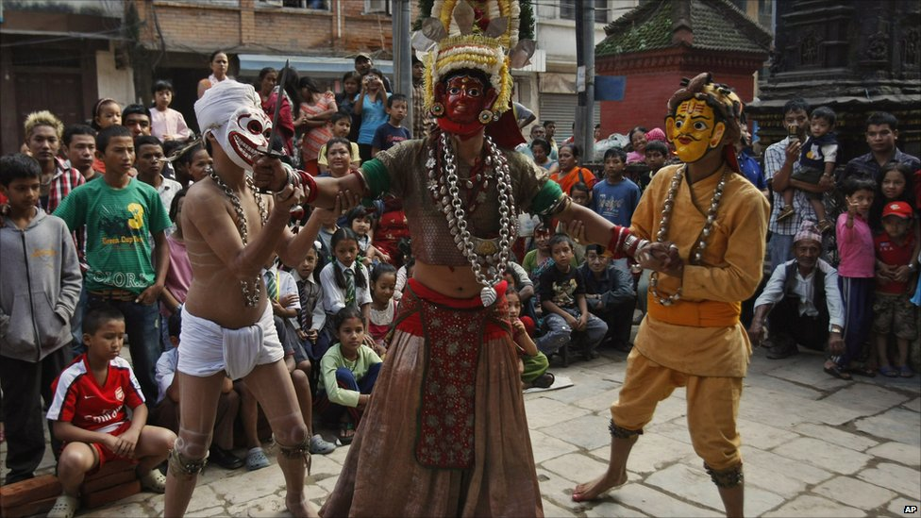

Goddess Kumari.

On the third day of the celebration (8 Sept), the living Goddess

Kumari is brought out into the streets in her special chariot from

the *Kumari-ghar*. Her attendants, Ganesh and Bhairab,represented

by two young boys, accompany living Goddess Kumari. It is on

this day that President of Nepal including all high level officers

of Nepal government attend the festivities.

During the festival, three chariots carrying human representations

of the deities – Kumari, Ganesh and Bhairav, accompanied by

musical bands are pulled along the predetermined festival routes

in Kathmandu three days - first day the chariots are pulled through

the southern part of town, second day through the northern part, and on the third day the procession passes through the central section at Kilāgal. Starting from the year 2012, the chariot of Kumari is pulled by an all-women's team on the third day of the Kumari jatra.

On the last day of the celebration the *Yasin* is pulled down, signalling the end of Indra Jatra festival and taken to the confluence of Bagmati and Bishnumati at Teku for putting it to rest.

*Source:* Internet News

**Committee Chairs’ Column:** *(This column is for use by chairpersons of 5 permanent committees: Club Administration, Membership, Public Relations, Service Projects, and the Rotary Foundation)*

Nothing for this column ?

On Lighter Side :

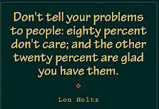



Great Quotes:

**[Don't walk behind me; I may not lead.](http://www.brainyquote.com/quotes/quotes/a/albertcamu100779.html" \o "view quote)**

**[Don't walk in front of me; I may not follow.](http://www.brainyquote.com/quotes/quotes/a/albertcamu100779.html" \o "view quote)**

**[Just walk beside me and be my friend.](http://www.brainyquote.com/quotes/quotes/a/albertcamu100779.html" \o "view quote)**

***-*** [***Albert Camus***](http://www.brainyquote.com/quotes/authors/a/albert_camus.html)

**Members’ Corner:** *(This column is for Club members to express anything they would like in matter of Club activities, Club administration, Club issues or on Breakfast Chatter, or on anything else that would be of interest to fellow members.)*

This remains empty!

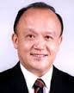

Rotary is based on the idea that our service is more effective when we serve

together with our friends. So let's enjoy our Rotary service, share it with others,

and *Light Up Rotary* together!

.

**RI President GARY C.K. HUANG**

Please send information on club activities, progress reviews on service projects, relevant photos etc to:

BC Editor: RR Shrestha email: rryesrr@gmail.com

## 12 September 2014 The Weekly Bulletin of Rotary Club of Kathmandu Mid-Town bc-11/9.014